**Computer Programming**

**(FCCS0102)**

**Practical File**

**(1st SEM)**

Submitted by:- Submitted to:-

Name – Dhruv Gupta Ms. Vidhu Jain

Roll No. – 2024UCI8045

Branch & Grp – CSIOT (2nd Grp)



Netaji Subhas University Of Technology, New Delhi

**INDEX**

|  |  |  |
| --- | --- | --- |
| **Serial Number** | **Practical Name** | **Teacher’s Signature** |
| 1 | Install Python and set up the development environment. |  |
| 2 | Write a Python program to print "Hello, World!". |  |
| 3 | Write a Python program to calculate the area of a circle given the radius. |  |
| 4 | Perform basic arithmetic operations on variables. |  |
| 5 | Write a Python program to check if a number is even or odd. |  |
| 6 | Implement a simple calculator using conditional statements. |  |
| 7 | Write a Python program to print the Fibonacci series using a for loop. |  |
| 8 | Use a while loop to find the factorial of a number. |  |
| 9 | Write a function to calculate the sum of two numbers. |  |
| 10 | . Implement a function to check if a given string is a palindrome. |  |
| 11 | Perform various operations on lists (e.g., sorting, slicing). |  |
| 12 | Use dictionaries to store and retrieve student grades. |  |
| 13 | Create a class to represent a book with attributes and methods. |  |
| 14 | Implement inheritance by creating subclasses for different types of books. |  |
| 15 | Write a generator function to generate the Fibonacci series. |  |
| 16 | Use lambda functions, map, and filter to perform operations on a list. |  |
| 17 | Create a module that contains functions for mathematical operations. |  |
| 18 | Import and use functions from external packages (e.g., math, random). |  |
| 19 | Create and manipulate NumPy arrays. |  |
| 20 | Perform basic operations and indexing on arrays. |  |

**QUESTION-1.)** **Install Python and set up the development environment.**

**Solution-1.)**

Install Python and set up the development environment

Description: Install Python from python.org and set up a development environment such as VS Code, PyCharm, or use the command-line terminal with a text editor.

Steps:

Download Python and install it.

Set up an IDE or use the terminal.

**QUESTION-2.)** **Write a Python program to print "Hello, World!"**

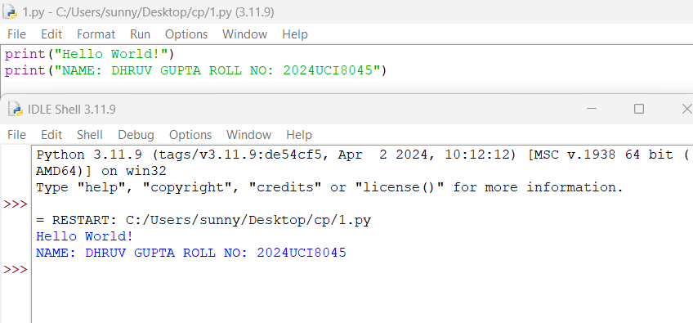

**QUESTION-3.) Write a Python program to calculate the area of a circle given the radius.**

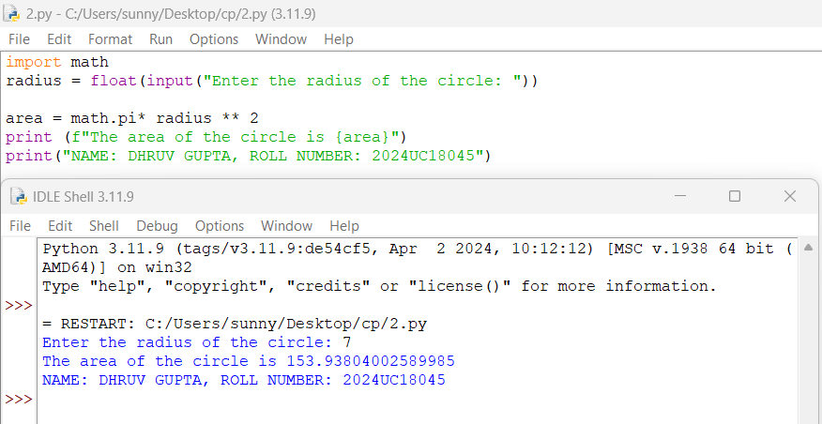

**QUESTION-4.) Perform basic arithmetic operations on variables.**

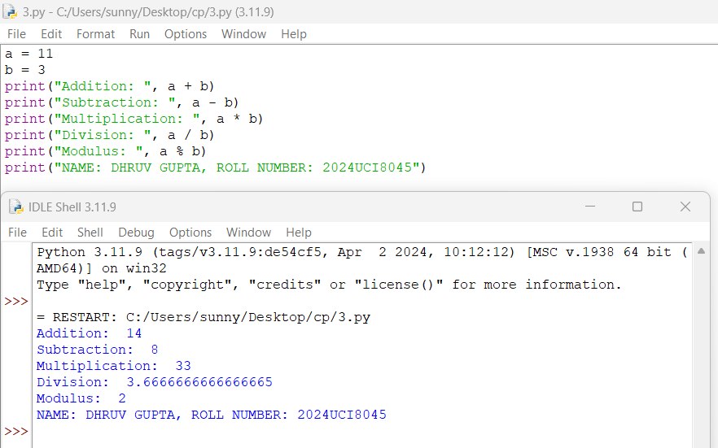

**QUESTION-5.) Write a Python program to check if a number is even or odd.**

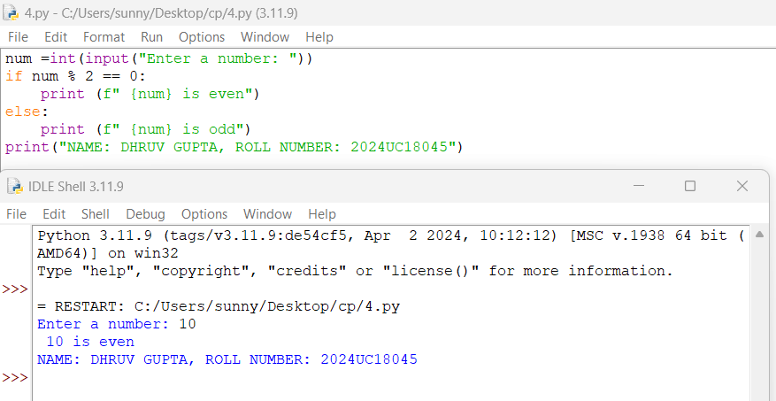

**QUESTION-6.) Implement a simple calculator using conditional statements.**

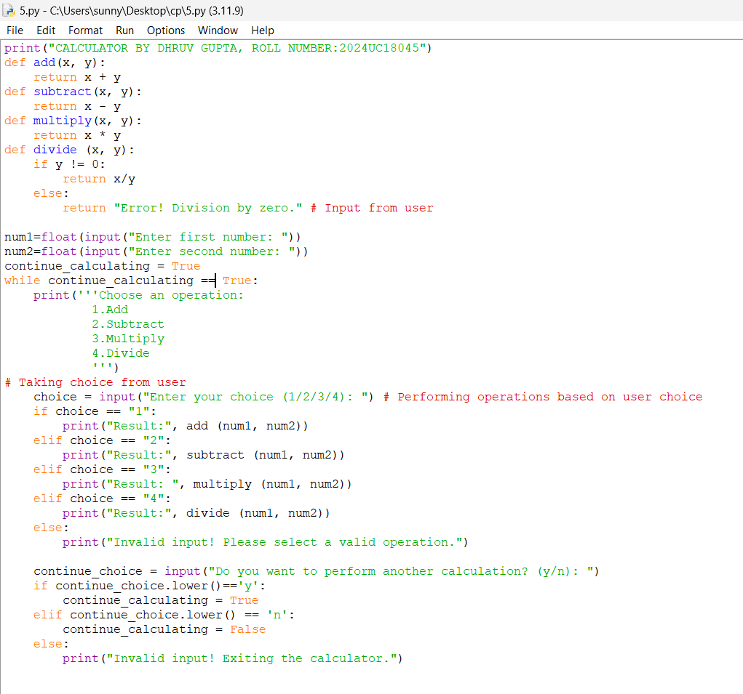

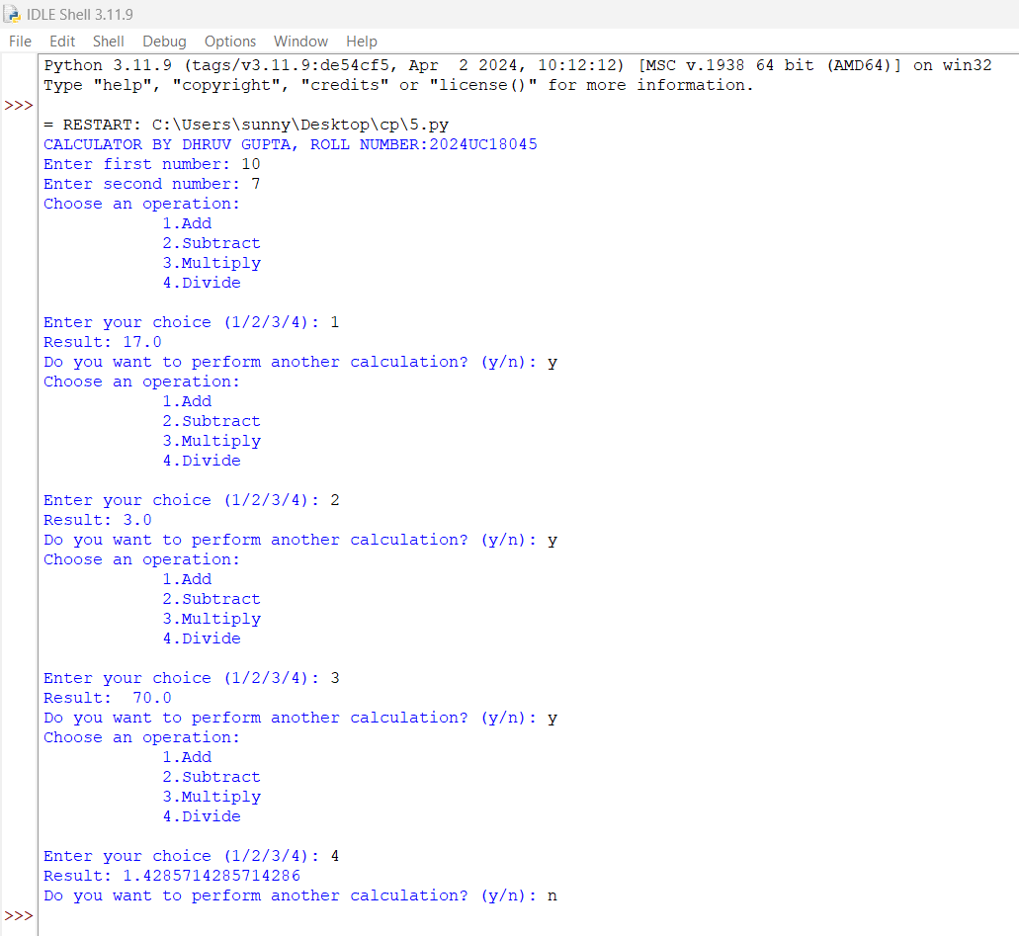

**QUESTION-7.) Write a Python program to print the Fibonacci series using a for loop.**

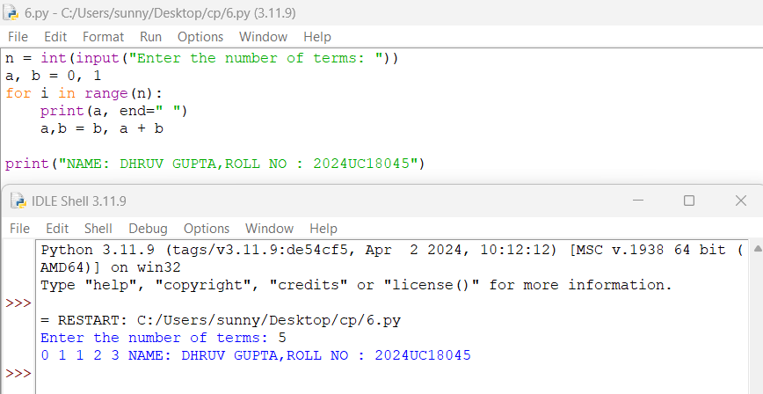

**QUESTION-8.) Use a while loop to find the factorial of a number.**

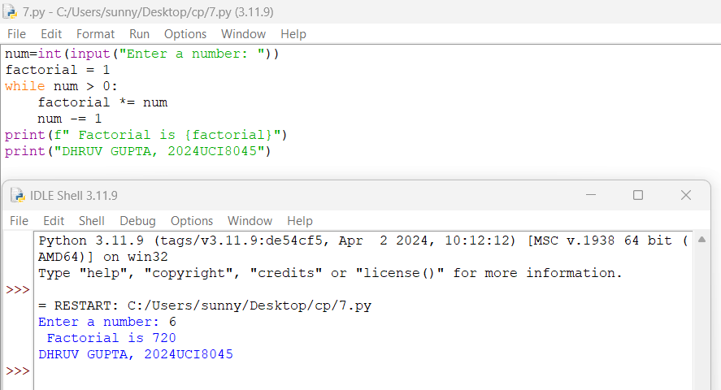

**QUESTION-9.) Write a function to calculate the sum of two numbers.**

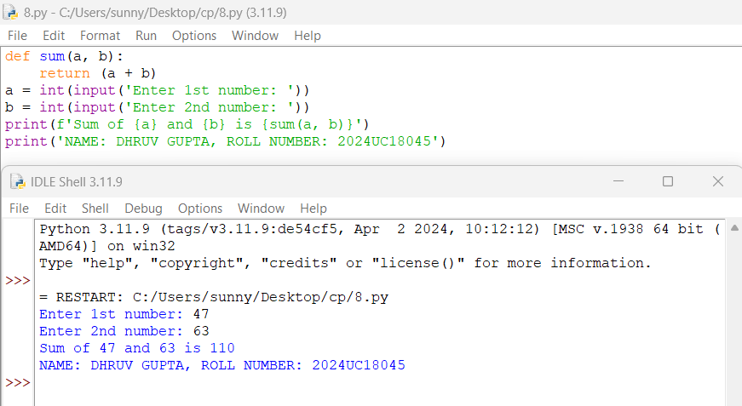

**QUESTION-10.) Implement a function to check if a given string is a palindrome.**

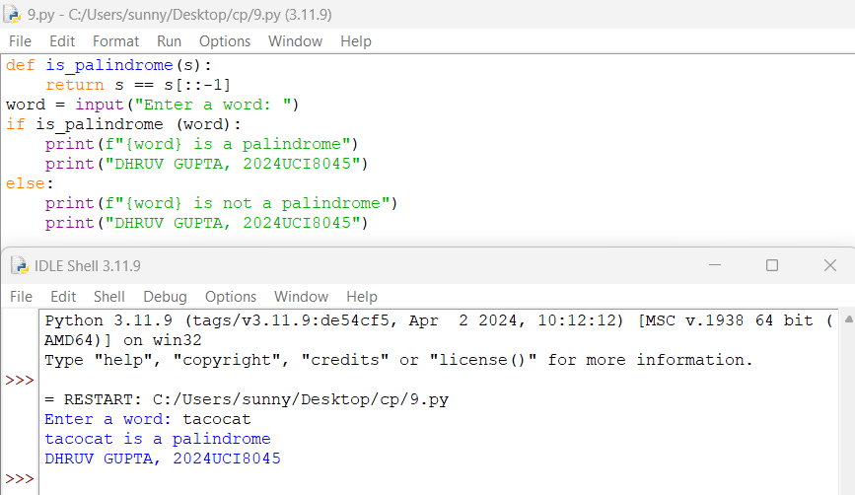

**QUESTION-11.) Perform various operations on lists (e.g., sorting, slicing).**

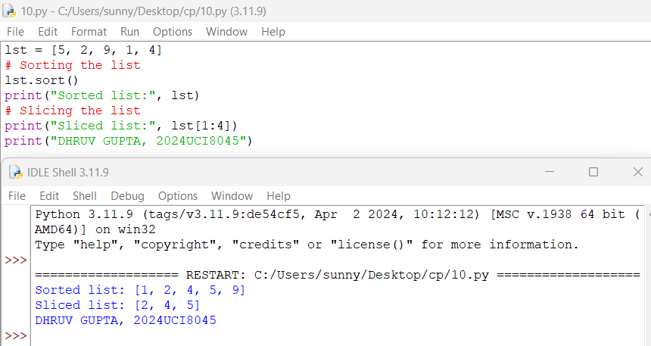

**QUESTION-12.) Use dictionaries to store and retrieve student grades.**

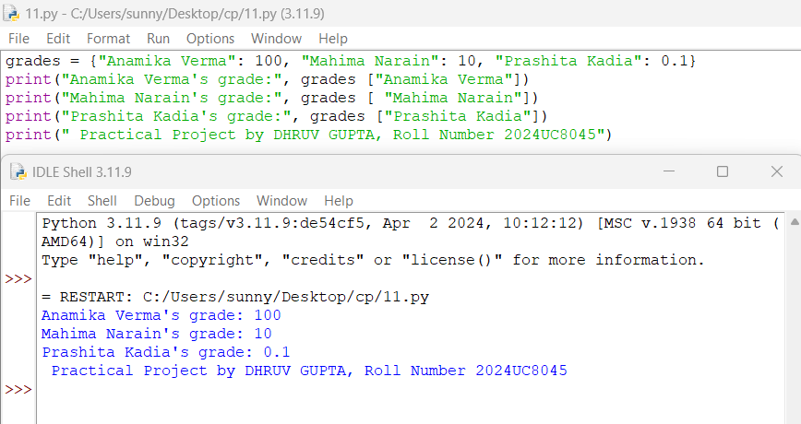

**QUESTION-13.) Create a class to represent a book with attributes and methods.**

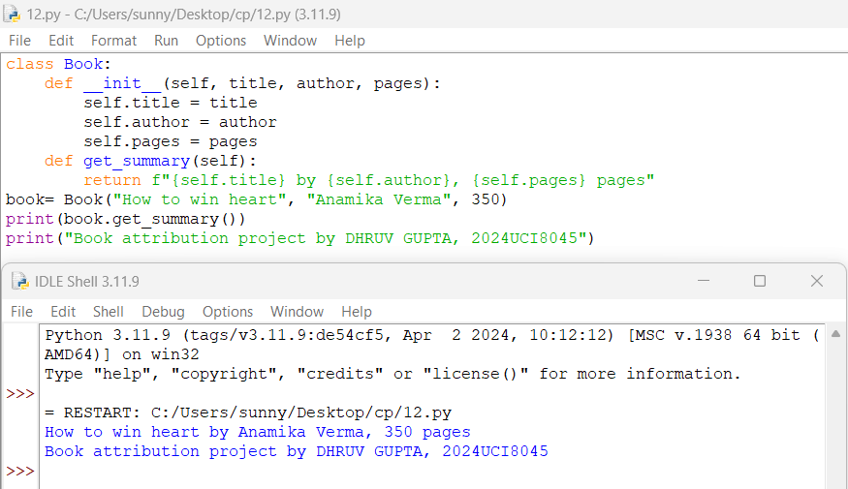

**QUESTION-14.) Implement inheritance by creating subclasses for different types of books.**

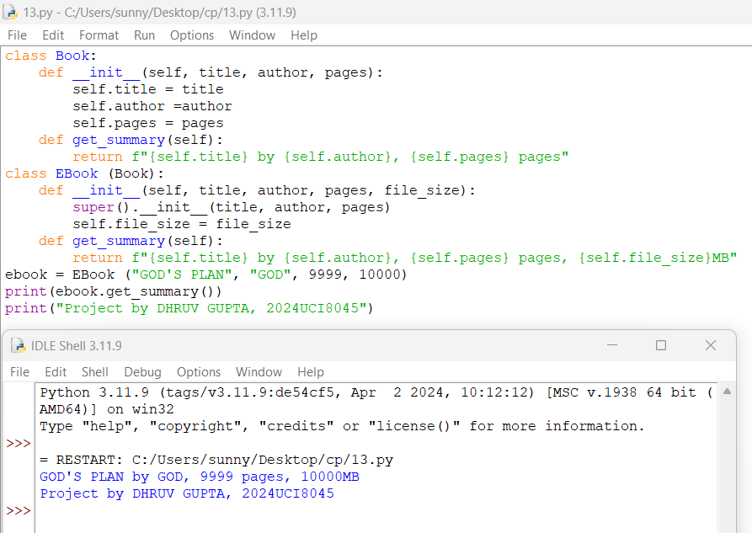

**QUESTION-15.) Write a generator function to generate the Fibonacci series.**

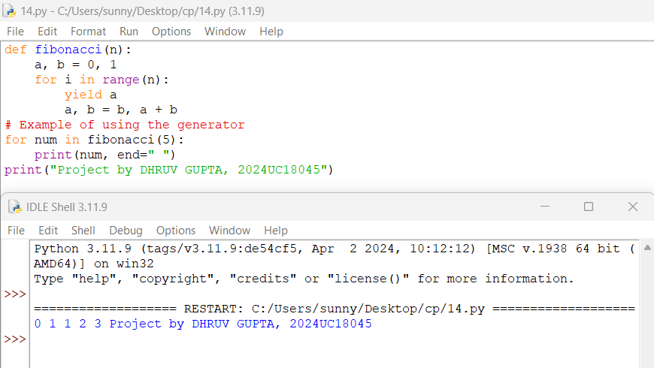

**QUESTION-16.) Use lambda functions, map, and filter to perform operations on a list.**

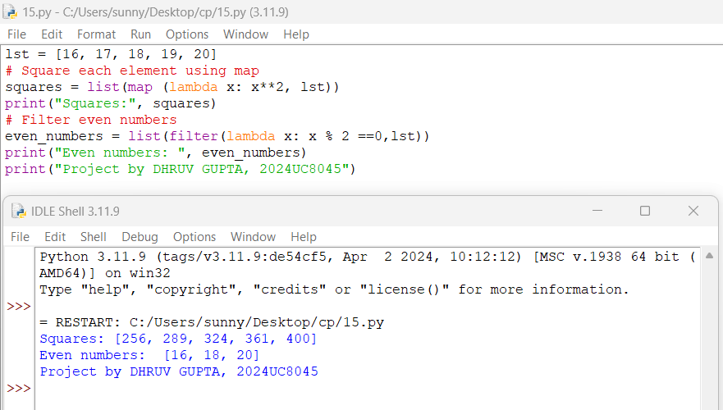

**QUESTION-17.) Create a module that contains functions for mathematical operations**

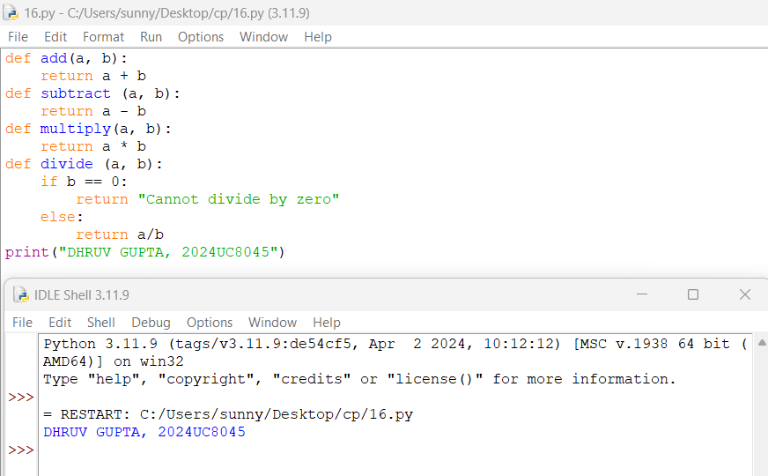

**QUESTION-18.) Import and use functions from external packages (e.g., math, random.**

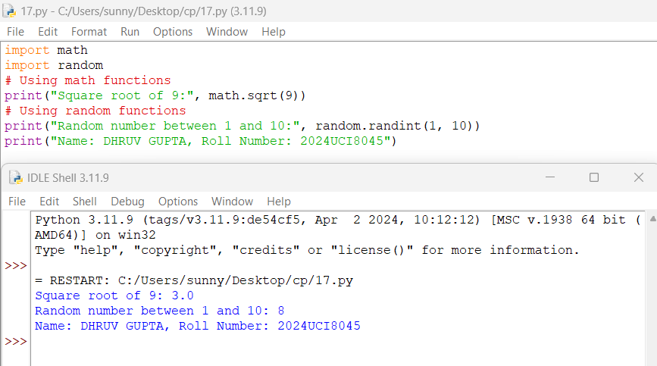

**QUESTION-19.) Create and manipulate NumPy arrays.**

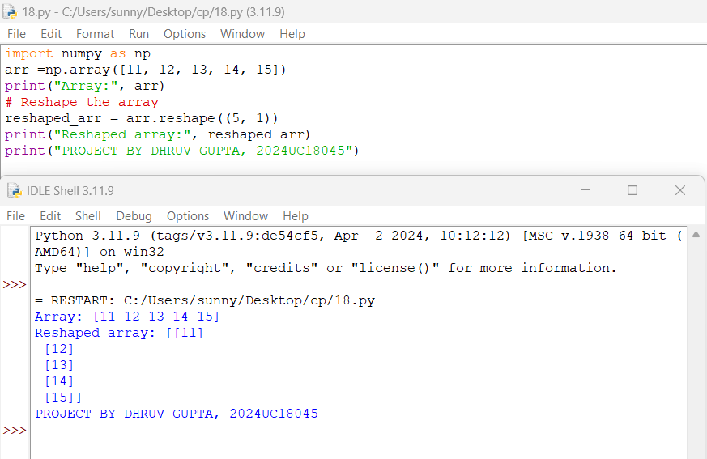

**QUESTION-20.) Perform basic operations and indexing on arrays.**

